Title Page:
Enhancing Rating Accuracy Through Quantitative Survey on Medication Reminder App for a Comparative Study between Android Application and iOS Application

Nisha. N1, Dr T Suresh Balakrishnan2
Nisha N¹
Research Scholar,
Department of Computer Science Engineering,
Saveetha School of Engineering,
Saveetha Institute of Medical and Technical Sciences,
Saveetha University, Chennai, Tamil Nadu, India. Pin code: 602105
192011495L.sse@saveetha.com

Dr T Suresh Balakrishnan²
Project Guide, Corresponding Author
Department of Computer Science Engineering,
Saveetha School of Engineering,
Saveetha Institute of Medical and Technical Sciences,
Saveetha University, Chennai, Tamil Nadu, India. Pin code: 602105
sureshbalakrishnant.sse@saveetha.com

Keywords: iOS Application, Android Application, Rating Accuracy, Medication-Reminder, Treatment, Research
ABSTRACT:

Aim: The objective of this study is to examine the rating accuracy that users spend navigating the Medication-Reminder iOS and Android applications throughout therapy. Materials and Methods: An iOS and Android text summary application will be used by a sample of 10 participants to enhance the assessment of Rating Accuracy in treatment procedures. To find the right sample size, a power analysis with 80% power will be used. Result: The iOS application beats the Android application with a Rating Accuracy of 93.00% rating accuracy, despite the Android application's assessment of treatment indicating a Rating Accuracy of 87.67% rating accuracy. A p-value of 0.001 (p < 0.05) indicates statistically significant differences between the Android and iOS platforms. Conclusion: The iOS application shows a Rating Accuracy of 93.00% rating accuracy, whilst the Android application shows a Rating Accuracy of 87.67% rating accuracy. This emphasizes how differently the two platforms behave.

Keywords: iOS Application, Android Application, Rating Accuracy, Medication-Reminder, Treatment, Research

INTRODUCTION:

The rating accuracy between the Medication-Reminder iOS and Android applications is quantitatively analyzed in this study as it relates to the course of therapy. The study employs precise measurements to detect variations in the two systems' user experiences and system performance (Baumgartner et al. 2021). This provides developers with chances to refine interfaces and raise consumer contentment in an iterative manner (Fishbein et al. 2017). These insights enable organizations to make well-informed decisions about activities connected to treatment, promoting maximum engagement through the use of Medication (Zhou et al. 2022). In the end, our research adds significant knowledge to the larger conversation on digital user experience, enabling the improvement of online application design to encourage smooth communication with medical systems (Salgado et al. 2018). Recognizing the significance of prompt responses in orthopedic support applications, we undertake a systematic inquiry to assess the effectiveness of the Medication-Reminder platform (Anderson, Burford, and Emmerton 2016).

In the expansive field of medication reminder research, numerous scholarly resources are accessible through reputable platforms. For instance, the IEEE Xplore digital repository hosts (1,258 journals), while ScienceDirect offers access to a substantial collection of (178,590 articles). Additionally, the Google Scholar database contains an extensive repository comprising (3,270,000 articles), and Springer Publishers contribute (8,290 articles) to the available literature. This paper embarks on a comprehensive exploration of performance metrics concerning Rating Accuracy in the medication reminder application (Huang, Lum, and Car 2020). Through meticulous examination of rating accuracy for various actions and processes within the app, such as loading screens, feature accessibility, and command execution, we aim to provide a comprehensive overview of its responsiveness (van Kerkhof et al. 2016). Furthermore, we endeavor to pinpoint potential bottlenecks or inefficiencies that may impede user experience and productivity (Hale, Capra, and Bauer 2015). By conducting a thorough performance analysis, we aspire to offer actionable recommendations for optimizing the Medication-Reminder application to ensure seamless functionality and enhance user satisfaction. Moreover, this study contributes valuable insights to the broader discourse on mobile application performance evaluation, with implications for improving the usability and effectiveness of orthopedic assistance tools like Medication-Reminder (Tabi et al. 2019). Recognizing the significance of prompt responses in orthopedic support applications, we undertake a systematic inquiry to assess the effectiveness of the Medication-Reminder platform. Ultimately, our findings will inform developers and stakeholders about opportunities for enhancement and optimization to elevate user experience and satisfaction (Krebs and Duncan 2015). By deepening our understanding of Rating Accuracy dynamics, this research contributes to the advancement of mobile health technology and orthopedic care.
In technology-driven philanthropy, assessing the efficacy of online apps is essential to guaranteeing seamless and user-friendly treatment procedures. The focus of this study is to compare the Rating Accuracy for the Medication-Reminder iOS platform and its Android equivalent during the contributing process (Bohlmann, Mostafa, and Kumar 2021). To fill a significant vacuum in the existing research, this study attempts to illuminate user engagement dynamics unique to treatment transactions by examining the subtle characteristics of digital philanthropy (Krebs and Duncan 2015). With an interdisciplinary research team that includes specialists in human-computer interface, philanthropy, and usability, the project is poised to offer thorough insights. The ultimate objective is to provide empirical data on the functionality of the iOS and Android platforms of the Medication-Reminder application during treatment procedures to enhance user experiences in the context of digital therapy (Grayek et al. 2023).

Materials & Methods:

The Saveetha School of Engineering's Computer Science and Engineering department, which is a component of the larger Saveetha Institute of Medical and Technical Sciences, is home to the Ideation Laboratory, where the study is conducted. This research adopts a systematic methodology with two groups: Group 1 investigates the details of the Android application, while Group 2 explores the world of iOS applications (Shen et al. 2021). The study estimates the ideal iteration sample size by using a strong approach, setting the G-power at a strong 80%, and utilizing the analytical capability of the Clincalc Website. The study carefully calculates the number of iterations that are acceptable, deciding on 10 for each group, yielding a sample size of 24 in total (Shen et al. 2021).

XAMPP is a software program designed to simplify the setup of a local web server environment on a PC, making it efficient and user-friendly. It streamlines the creation and configuration of essential components necessary for Android development, allowing users to easily install and operate a fully functional web server on their computers. The acronym "XAMPP" stands for its key components: Apache, MariaDB (formerly MySQL), PHP, and Perl. XAMPP primarily serves the purpose of facilitating the development and testing of websites and Android applications in a controlled local environment before deployment to a live server. This eliminates the hassle of users having to install and manage individual components like web servers, database servers, and programming languages. By providing developers with a quick setup for a local server environment closely resembling a production server's setup, XAMPP enables thorough testing of the functionality and compatibility of Android applications without requiring an internet connection. Particularly beneficial for developers working with PHP and MySQL, given that these components are included in the XAMPP package, it offers a reliable and intuitive solution for simplifying the setup of a local web server. This streamlined process allows developers to dedicate more time to building and refining their Android projects in a secure environment on their personal computers. Overall, XAMPP emerges as a valuable tool for Android developers worldwide, thanks to its quick and straightforward setup process for local server development and testing, coupled with its intuitive interface and comprehensive features.

The architecture of the iOS application incorporates a specialized API aimed at facilitating seamless connectivity with the XAMPP server. Utilizing the Swift programming language, the application effectively manages and interacts with this API. Typically, HTTP GET requests are employed to communicate with specific API endpoints, triggering corresponding PHP scripts on the server. These PHP scripts serve as handlers for the API, retrieving relevant data from the database and formatting it into the widely used JSON format before transmitting it back to the iOS application. This systematic approach enhances the efficiency and effectiveness of data transfer between the application and the server. Similarly, within the Android application, PHP code is embedded to handle the connection to the XAMPP server. PHP scripts play a crucial role in establishing communication with the server's MySQL database, facilitating simplified access and manipulation of stored data. This intricate process ensures seamless interaction between the Android application and the MySQL database hosted on the XAMPP server. PHP scripts serve as versatile intermediaries, enabling dynamic engagement with the database through SQL queries to address the evolving data requirements of the Android application.

iOS application

This project aims to improve the system to provide consumers with a more responsive and seamless experience. To minimize navigation delays and Rating Accuracy during treatment and medical request procedures inside the Medication-Reminder iOS application, Group 1's preparations use the application as a point of reference. Through strategic enhancements and improved procedures, the goal is to ensure prompt communication and minimize delays, ultimately improving the overall efficiency of the application for treatment in the dynamic medication reminder environment. Table 1 offers more information by displaying the iOS application's pseudocode and encapsulating the central processor unit.

Android application

Our main goal in optimizing our system's responsiveness and user experience is to improve the system architecture. Group 2 will use the Medication-Reminder Android application as a model application, concentrating on problems with navigation latency and Rating Accuracy during treatment processes. This entails using effective algorithms, modifying the server side, and optimizing the data. Our goal is to reduce latency and improve real-time updates by carefully adjusting these settings, allowing for seamless and pleasurable user engagement with the program. Furthermore, we can adjust the functionality of the Android application to match the changing requirements of Medication-Reminder users by incorporating user input and carrying out iterative testing—two essential components of the continuous development process. The pseudocode for the Android application is shown in Table 2.

Statistical Analysis

Many industry sectors recognize IBM SPSS as an important research tool for organizing statistical data. To assess significance, it provides a variety of frequently performed calculations, such as mean, F-value, degrees of freedom (df), and standard error (Wiecek et al. 2020)to comprehend and resolve delays in the Medication-Reminder application's Rating Accuracy during real-time navigation in treatment operations, two of the main goals of utilizing SPSS are computing Rating Accuracy and collecting resource allocation data from the dataset.

RESULTS

Table. 1 Provide the iOS app to consumers for review, get feedback, make iterations on changes, and methodically record feedback scores to ensure accurate evaluations for the Medication-Reminder application.

Table. 2 To guarantee rating accuracy, provide users access to the Medication-Reminder Android application, collect feedback, evaluate it for enhancements, iterate as needed, and record the importance of user input.

Table. 3 demonstrates that text data with a sample size of N = 10 has been supplied. Every 10 iterations, Rating Accuracy rates for both iOS and Android apps are computed. The iOS application performs better than the Android application in terms of accuracy.

Table. 4 This involves utilizing iOS and Android Development Algorithms to compare data from several samples. The average data hour for Android development is 87.67%, whereas the average data hour for iOS development is 93.00%. For iOS and Android development, the equivalent relative standard deviations are 1.954 and 3.310, in that order. The standard error mean for iOS and Android development is 0.564 and 0.956, respectively.

Table. 5 Using a T-Test and a 95% confidence interval in statistically independent samples, the iOS and Android Development Algorithm are compared. With a p-value of 0.001 (p<0.05), the results show a statistically significant difference between the iOS and Android Development algorithms.

Fig. 1 The figure displays the patient dashboard screen of the Medication-Reminder application from patient login where the patient can view his details, today's tasks, daily progress, videos for practice, and questionnaires for clarifications. The patient can also access WhatsApp chat for any assistance.

Fig. 2 Based on the comparison, the average Rating Accuracy for the Android development process is 87.67%, whereas the iOS algorithm's is 93.00%. The mean Rating Accuracy is plotted on the Y-axis, while the comparison of the development methodologies for iOS and Android is plotted on the X-axis, with error bars extending to ±2 standard deviations.

Fig. 3 shows the database table of Medication-Reminder related to the doctor details such as doctor ID, doctor password, doctor name, doctor contact, doctor age, doctor gender, and doctor mail. These details are displayed in the application on the doctor’s profile page and also used in the patient log-in to know the doctor's details.

DISCUSSION

The outcome of an independent sample T-test analysis yields the significance value. To summarise, the Android application runs slower than the iOS application, having 87.67% rating accuracy to construct, whereas the iOS version operates at a quicker pace of 93.00% rating accuracy. With a determined significance level of 0.001, a value less than 0.05 is indicated.

This research delves into the crucial doctor-patient relationship, examining the Rating Accuracy involved in treatment procedures through iOS and Android applications. It underscores the importance of timely responses and investigates how real-time monitoring provided by Android and iOS platforms enhances user experience (Badawy and Kuhns 2016). Furthermore, the study emphasizes the significance of technological solutions such as efficient algorithms and data optimization in addressing navigation delays and improving system architecture (Greenstein et al. 2021). Additionally, it elucidates the iterative processes of continuous testing and user feedback within the Medication-Reminder framework (Waselewski et al. 2021). Discussions predominantly center around enhancing Rating Accuracy, refining user interfaces, and strategically leveraging technology to improve the effectiveness of Medication-Reminder's treatment procedures (Schoenthaler et al. 2020). The research highlights the iterative nature of the Medication-Reminder platform's user feedback process, emphasizing ongoing testing and enhancement to better align with user experiences and preferences (Thompson et al. 2017). This iterative approach not only showcases the platform's adaptability to user demands but also serves as a deliberate strategy to maximize Medication-Reminder's overall effectiveness (Israni et al. 2016).

The project's ability to accomplish its goals depends on several essential elements cooperating. Progress requires sufficient human, financial, and technical resources. To guide the project toward its intended outcomes, well-defined goals, and deadlines must be combined with efficient planning and implementation. To create a common understanding and commitment to the project's goals, active participation and open communication are essential. Success depends on using effective risk management techniques, such as recognizing and resolving hurdles. For projects to be completed efficiently, the right technology and tools must be chosen and used. Legally significant projects have to abide by all applicable rules and regulations. The project team's proficiency and cooperative efforts are also important factors in the outcome.

CONCLUSION

With a focus on treatment procedures, we analyzed the Medication-Reminder apps for iOS and Android and discovered that the Android application required more Rating Accuracy than the iOS version. We performed an analysis based on a resource allocation dataset and discovered a significant difference in the Rating Accuracies of the two systems. Notably, the iOS software has 93.00% rating accuracy of Rating Accuracy, but the Android app requires 87.67% rating accuracy, demonstrating how accurately it calculated network demand. Our research surprisingly shows that the iOS app conveys information more efficiently than the Android counterpart. The calculated p-value of 0.001 indicates the statistical significance of the comparison (p<0.05).

REFERENCES

Anderson, Kevin, Oksana Burford, and Lynne Emmerton. 2016. “App Chronic Disease Checklist: Protocol to Evaluate Mobile Apps for Chronic Disease Self-Management.” JMIR Research Protocols 5 (4): e6194.
Badawy, Sherif M., and Lisa M. Kuhns. 2016. “Economic Evaluation of Text-Messaging and Smartphone-Based Interventions to Improve Medication Adherence in Adolescents with Chronic Health Conditions: A Systematic Review.” JMIR mHealth and uHealth 4 (4): e6425.
Baumgartner, Susan L., D. Eric Buffkin Jr, Elise Rukavina, Jason Jones, Elizabeth Weiler, and Tony C. Carnes. 2021. “A Novel Digital Pill System for Medication Adherence Measurement and Reporting: Usability Validation Study.” JMIR Human Factors 8 (4): e30786.
Bohlmann, Aaron, Javed Mostafa, and Manish Kumar. 2021. “Machine Learning and Medication Adherence: Scoping Review.” JMIRx Med 2 (4): e26993.
Fishbein, Joel Nathan, Lauren Ellen Nisotel, James John MacDonald, Nicole Amoyal Pensak, Jamie Michele Jacobs, Clare Flanagan, Kamal Jethwani, and Joseph Andrew Greer. 2017. “Mobile Application to Promote Adherence to Oral Chemotherapy and Symptom Management: A Protocol for Design and Development.” JMIR Research Protocols 6 (4): e6198.
Grayek, Emily, Tamar Krishnamurti, Lydia Hu, Olivia Babich, Katherine Warren, and Baruch Fischhoff. 2023. “Collection and Analysis of Adherence Information for Software as a Medical Device Clinical Trials: Systematic Review.” JMIR mHealth and uHealth 11 (1): e46237.
Greenstein, Jay, Robert Topp, Jena Etnoyer-Slaski, Michael Staelgraeve, and John McNulty. 2021. “Effect of a Mobile Health App on Adherence to Physical Health Treatment: Retrospective Analysis.” JMIR Rehabilitation and Assistive Technologies 8 (4): e31213.
Hale, Kelli, Sandra Capra, and Judy Bauer. 2015. “A Framework to Assist Health Professionals in Recommending High-Quality Apps for Supporting Chronic Disease Self-Management: Illustrative Assessment of Type 2 Diabetes Apps.” JMIR mHealth and uHealth 3 (3): e4532.
Huang, Zhilian, Elaine Lum, and Josip Car. 2020. “Medication Management Apps for Diabetes: Systematic Assessment of the Transparency and Reliability of Health Information Dissemination.” JMIR mHealth and uHealth 8 (2): e15364.
Israni, Ajay, Carl Dean, Brian Kasel, Lisa Berndt, Winston Wildebush, and C. Jason Wang. 2016. “Why Do Patients Forget to Take Immunosuppression Medications and Miss Appointments: Can a Mobile Phone App Help?” JMIR Public Health and Surveillance 2 (1): e5285.
Kerkhof, Linda Wilhelmina Maria van, Catharina Walthera Egbertha van de Laar, Charlie de Jong, Marjolein Weda, and Ingrid Hegger. 2016. “Characterization of Apps and Other E-Tools for Medication Use: Insights Into Possible Benefits and Risks.” JMIR mHealth and uHealth 4 (2): e4149.
Krebs, Paul, and Dustin T. Duncan. 2015. “Health App Use Among US Mobile Phone Owners: A National Survey.” JMIR mHealth and uHealth 3 (4): e4924.
Salgado, Teresa M., Alexa Fedrigon, Donna Riccio Omichinski, Michelle A. Meade, and Karen B. Farris. 2018. “Identifying Medication Management Smartphone App Features Suitable for Young Adults With Developmental Disabilities: Delphi Consensus Study.” JMIR mHealth and uHealth 6 (5): e9527.
Schoenthaler, Antoinette, Michelle Leon, Mark Butler, Karsten Steinhaeuser, and William Wardzinski. 2020. “Development and Evaluation of a Tailored Mobile Health Intervention to Improve Medication Adherence in Black Patients With Uncontrolled Hypertension and Type 2 Diabetes: Pilot Randomized Feasibility Trial.” JMIR mHealth and uHealth 8 (9): e17135.
Shen, Chunying, Bin Jiang, Qilian Yang, Chengnan Wang, Kevin Z. Lu, Meng Gu, and Jing Yuan. 2021. “Mobile Apps for Drug–Drug Interaction Checks in Chinese App Stores: Systematic Review and Content Analysis.” JMIR mHealth and uHealth 9 (6): e26262.
Tabi, Katarina, Abnashi Singh Randhawa, Fiona Choi, Zamina Mithani, Friederike Albers, Maren Schnieder, Mohammadali Nikoo, et al. 2019. “Mobile Apps for Medication Management: Review and Analysis.” JMIR mHealth and uHealth 7 (9): e13608.
Thompson, David, Teresa Mackay, Maria Matthews, Judith Edwards, Nicholas Peters, and Susan B. Connolly. 2017. “Direct Adherence Measurement Using an Ingestible Sensor Compared With Self-Reporting in High-Risk Cardiovascular Disease Patients Who Knew They Were Being Measured: A Prospective Intervention.” JMIR mHealth and uHealth 5 (6): e6998.
Waselewski, Marika Elise, Tabor Elisabeth Flickinger, Chelsea Canan, William Harrington, Taylor Franklin, Kori Nicole Otero, Jacqueline Huynh, et al. 2021. “A Mobile Health App to Support Patients Receiving Medication-Assisted Treatment for Opioid Use Disorder: Development and Feasibility Study.” JMIR Formative Research 5 (2): e24561.
Wiecek, Elyssa, Andrea Torres-Robles, Rachelle Louise Cutler, Shalom Isaac Benrimoj, and Victoria Garcia-Cardenas. 2020. “Impact of a Multicomponent Digital Therapeutic Mobile App on Medication Adherence in Patients with Chronic Conditions: Retrospective Analysis.” Journal of Medical Internet Research 22 (8): e17834.
Zhou, Ting Ting, Rui Wang, Si Jia Gu, Li Ling Xie, Qing Hua Zhao, Ming Zhao Xiao, and Yu Lu Chen. 2022. “Effectiveness of Mobile Medical Apps in Ensuring Medication Safety Among Patients With Chronic Diseases: Systematic Review and Meta-Analysis.” JMIR mHealth and uHealth 10 (11): e39819.

TABLES AND FIGURES
Table 1. Provide the iOS app to consumers for review, solicit input, make iterative modifications, and document feedback values to guarantee rating accuracy.

Input: Accessing the Medication-Reminder appointment request
Output: Rating Accuracy(%)
Step 1: Showcase the iOS app to a chosen group of users so they may test and evaluate it.
⇒sampleUsers = selectSampleUsers()
⇒presentApplicationToUsers(sample users)
Step 2: Ask people to comment on what they think and flag any mistakes or suggestions.
⇒userFeedback = gatherUserFeedback(sampleUsers)
Step 3: Review the received feedback to understand user opinions and potential improvements.
⇒analyzeUserFeedback(userFeedback)
Step 4: Make the required corrections and enhancements in light of the input you have received.
⇒ Make improvements (user feedback)
Step 5: Iterate through stages 1-4 as needed, making constant improvements to the display based on user input.
⇒sampleUsers = selectSampleUsers()
⇒presentApplicationToUsers(sample users)
⇒userFeedback = gather user feedback(sample users)
⇒analyzeUserFeedback(user feedback)
⇒makeImprovements(userFeedback)
Step 6: Inform users of any updates and express gratitude for their thoughtful feedback.
⇒notifyUsersOfUpdates()
Step 7: Take note of and record each user's feedback value
⇒recordFeedback(userFeedback)

Table 2. Give consumers access to the Android application, solicit feedback, examine it for flaws, make any required iterations, and record the importance of user input to guarantee rating accuracy.

Input: Accessing the Medication-Reminder appointment request
Output: Rating Accuracy(%)
Step 1: Give users access to the Android application so they may experiment and learn about its features.
⇒presentAndroidApplicationToUsers()
Step 2: Ask people to express their opinions, point out mistakes, and offer suggestions for enhancements.
⇒userFeedback = gatherUserFeedback()
Step 3: Examine the received input to comprehend user viewpoints and pinpoint areas in need of improvement.
⇒analyzeUserFeedback(userFeedback)
Step 4: Ensure a polished online application by making the required adjustments and enhancements in light of the input you've received.
⇒ Improvements (user feedback)
Step 5: Iterate through stages 1-4 as needed, making constant improvements to the online program based on customer input.
Even so, advancements in The following functions are required:
⇒while improvements needed ():
⇒presentAndroidApplicationToUsers()
⇒userFeedback = gatherUserFeedback()
⇒analyzeUserFeedback(userFeedback)
⇒makeImprovements(userFeedback)
Step 6: Monitor and document the significance of every user's input.
⇒recordFeedback(userFeedback)

Table 3. For the text data, a sample size of N = 10 is proposed to have been provided. The Rating Accuracy rates for iOS and Android apps are assessed every 10 iterations. In terms of accuracy, the iOS app performs better than the Android version.

S.No | Android Rating Accuracy (ms) | iOS Rating Accuracy (ms)
1 | 89 | 92
2 | 84 | 94
3 | 91 | 92
4 | 92 | 96
5 | 86 | 95
6 | 82 | 92
7 | 89 | 94
8 | 91 | 93
9 | 90 | 89
10 | 87 | 91

Table 4. This entails comparing data from several samples using the Android Development Algorithm and iOS. For Android development, the average data hour is 87.67%, whereas for iOS development, it is 93.00%. The corresponding relative standard deviations for iOS and Android development are 1.954 and 3.310, respectively. For iOS and Android development, the standard error mean is 0.564 and 0.956, respectively.

Group Statistics
 | Algorithm | N | Mean | Std. Deviation | Std. Error Mean
Rating Accuracy | "Android" | 10 | 87.67 | 3.310 | .956
 | "iOS" | 10 | 93.00 | 1.954 | .564

Table 5. A 95% confidence interval is used to compare statistically independent samples between the Android Development Algorithm and iOS using a T-Test. The results indicate a statistically significant difference between the iOS and Android Development algorithms, with a p-value of 0.001 (p<0.05).

Independent Samples Test
 |  | Levene's Test for Equality of Variances |  | t-test for Equality of Means
 |  | F | Sig. | t | df | Sig. (2-tailed) | Mean Difference | Std. Error Difference | 95% Confidence Interval of the Difference
 |  |  |  |  |  |  |  |  | Lower | Upper
Rating Accuracy | Equal variances assumed | 4.219 | .052 | -4.804 | 22 | .000 | -5.333 | 1.110 | -7.636 | -3.031
 | Equal variances not assumed |  |  | -4.804 | 17.830 | .000 | -5.333 | 1.110 | -7.667 | -3.000

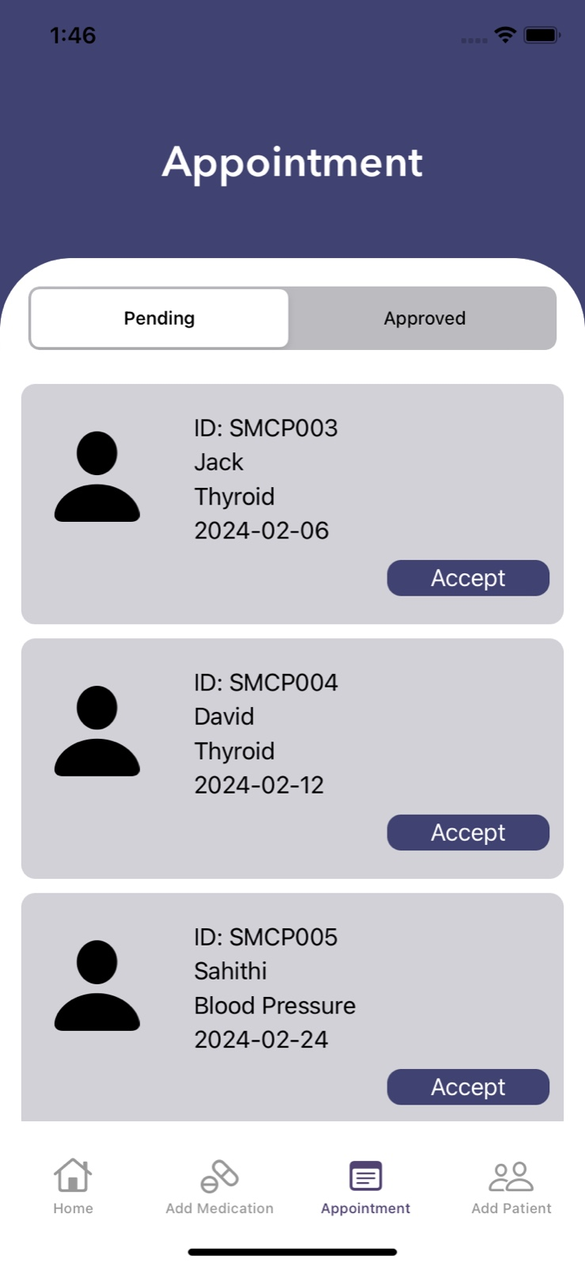
Fig. 1. The figure displays the patient Appointment screen of the Medication-Reminder application from the doctor login where the doctor can view his daily appointments for clarifications.

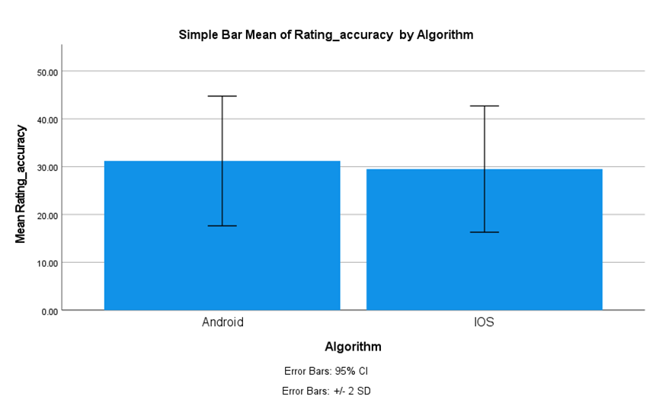
Fig. 2. Comparing the average Rating Accuracy frames of the two algorithms, the Android algorithm records an average of 87.67% while the iOS algorithm records an average of 93.00%. The X-axis displays the iOS and Android development process, while the Y-axis displays the average Rating Accuracy. The error bar is represented by two +/- 2 standard deviations.

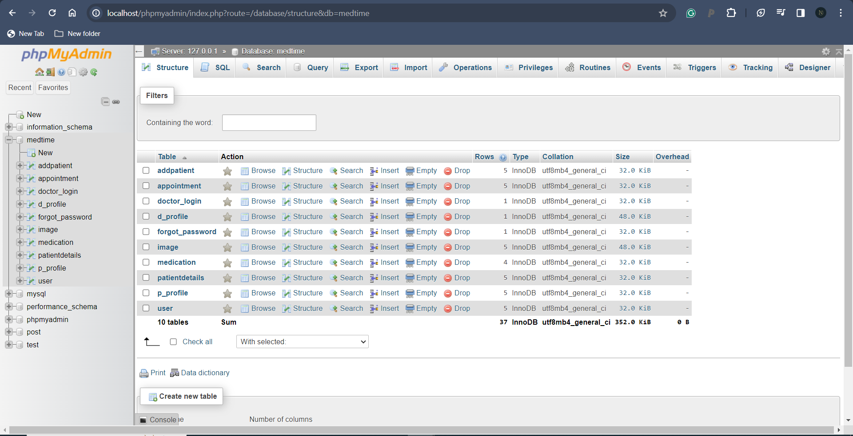
Fig. 3. shows the database table of Medication-Reminder related to the doctor details such as doctor ID, doctor password, doctor name, doctor contact, doctor age, and doctor gender. These details are displayed in the application on the doctor’s profile page and also used in the patient log-in to know the doctor's details.

